# Blackboard Formatting, Spell Check and Content Editor

Working in Blackboard can sometimes be tricky.    
To learn more about how to use it, see the Blackboard tips at <https://help.blackboard.com/Learn/Student/Add_and_Format_Content/Work_with_Text>. There are also a couple of tip sheets attached to this post.

1. You can use the **Preview function** to see how your post will look.

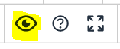

1. The **Clear Formatting function** is used to remove formatting. Highlight the text that needs fixing and select the Clear Formatting icon.



1. **Spell check is NOT on by default**. Please remember to manually click the spell check icon before you post.

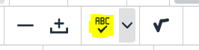

1. You add images, videos or other files by using the **Add Content** function. In the Editor, find the **Add Content button** and click on it.



Once the Add Content menu opens, click on the Insert Local Files option and navigate to the location where your image is currently stored.

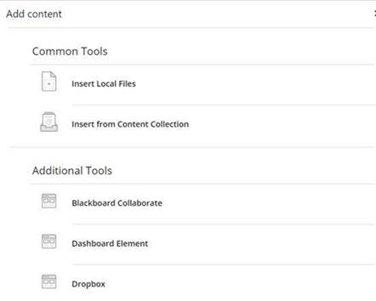

Select the image file you want to add and click Open to complete the process.

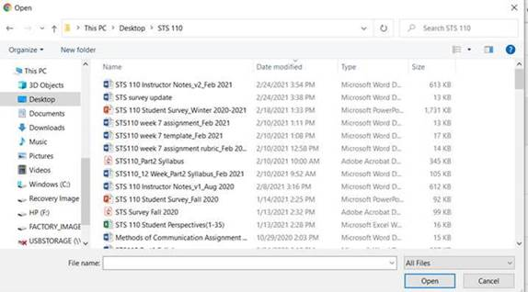

1. You may encounter issues with the way your completed assignment document looks in the system after you submit it. The **System Preview** is different than your actual document. When I'm assessing / grading your work, I use the actual document, not the preview. Below is an example:

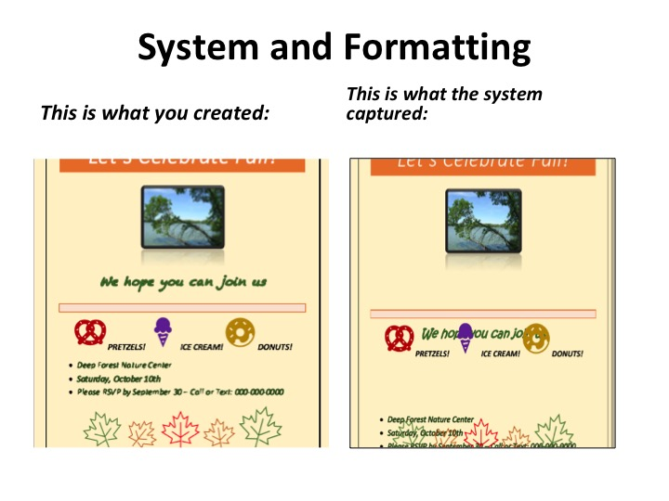

If you mess up something like a discussion post, let me know right away. It's often easily fixed when addressed early and I won't take off points if you do.

Please ask questions ("How do I do ....?") as you have them.